WooCommerce module for PayUmoney BOLT

for WooCommerce 3.x

with Shiprocket

Caution: Always keep backup of your existing WooCommerce installation including Mysql Database, before installing a new module.

Install via WordPress plugin Installer:-

1. Login to WordPress Admin panel and goto Add New Plugin. Then click on Upload Plugin.

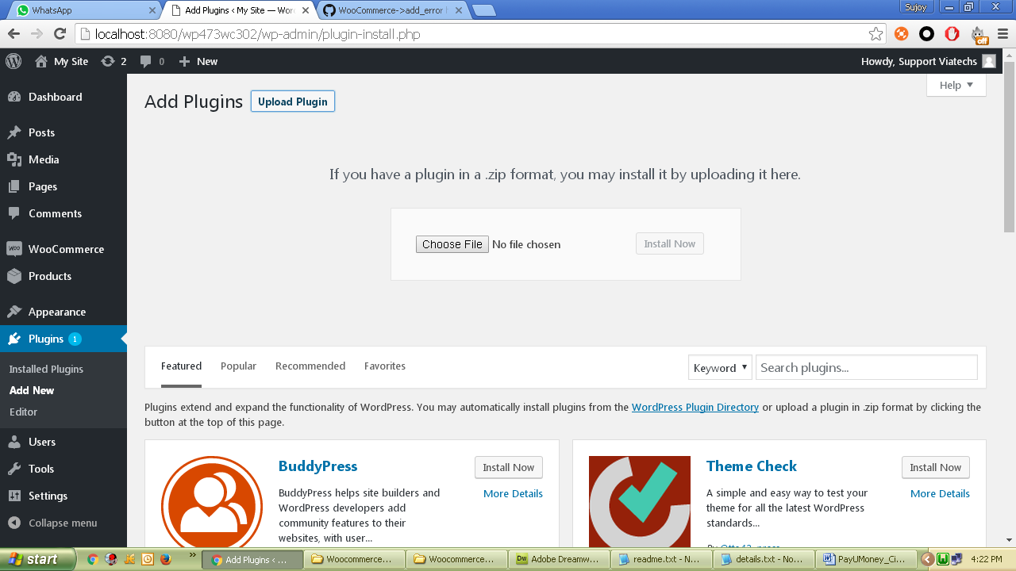

1. Choose this downloaded zip and click Install Now.

Manual Installation:-

1. Unzip and copy ‘WooCommerce_v3x_PayUmoney_BOLT_Shiprocket’ folder from this zip and paste/upload it to <wordpress root>\wp-content\plugins folder.
2. Login to WooCommerce admin and goto Plugins. Activate the plugin.

Configure Module:-

1. Login to WordPress admin and open WooCommerce Settings.

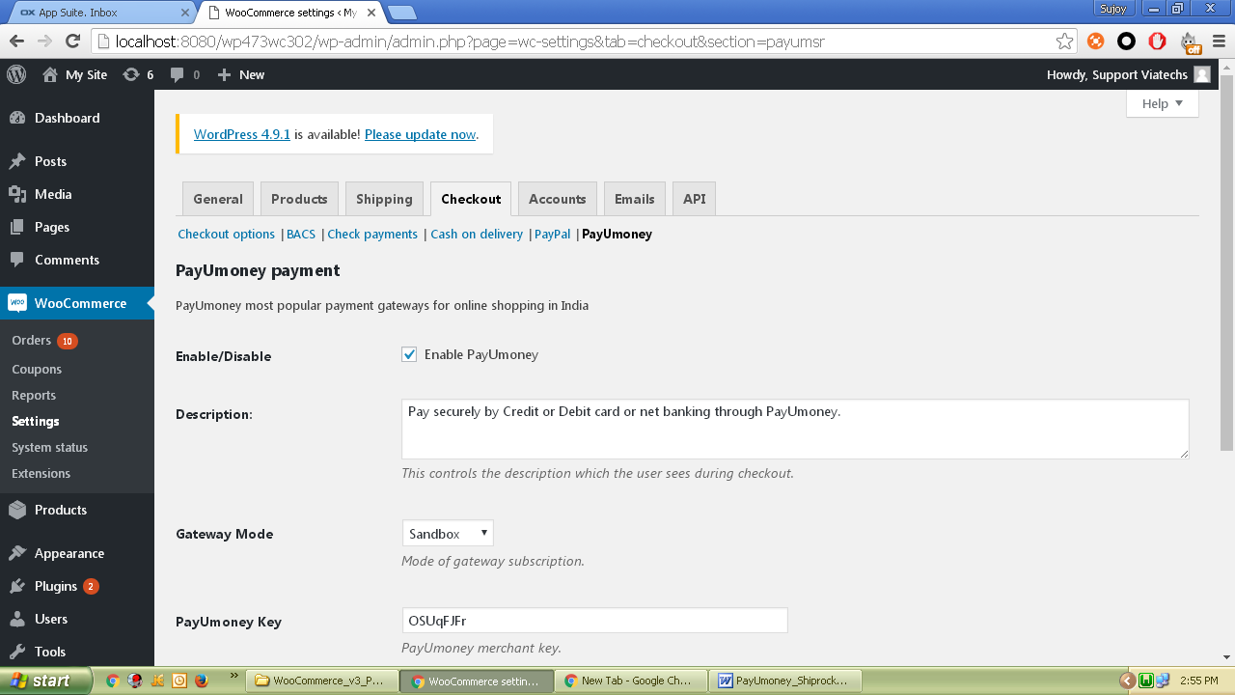

1. Click on Checkout tab and then on ‘PayUmoney’ plugin.

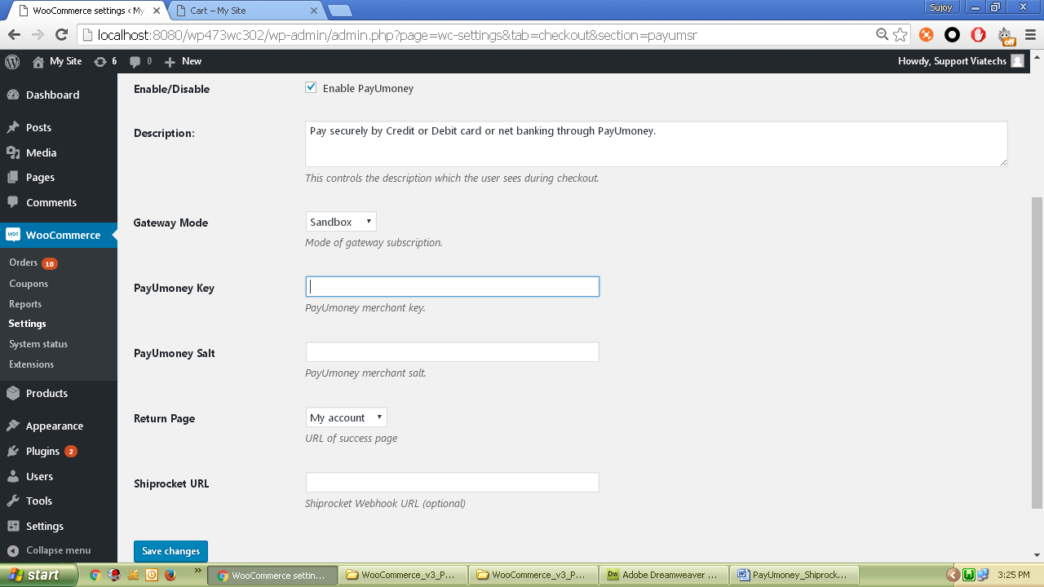

* + Enable/Disable – Tick to enable the module.
  + Description – Enter appropriate description to display at checkout.
  + Gateway Mode - “Sandbox” for sandbox/test operation and “Production” for live operation.
  + PayUmoney Key and Salt – Configure Merchant Key and Salt for PayUmoney.
  + Return Page – Use My Account as the default return page after payment response. You may create a custom page and select here. However, the custom page must contain appropriate WordPress / WooCommerce codes to show custom massages. Refer WordPress / WooCommerce development guide for custom pages.
  + Shiprocket URL – This is where the Shiprocket webhook url to be entered. Once entered, for each successful checkout, the order details will be posted to Shiprocket URL.

1. Now click save and customer will get PayUmoney option during checkout process.

